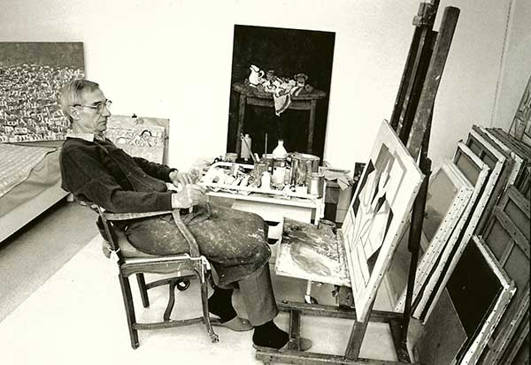

PIERRE COQUET

COQUET was born in Limos (South France) in 1926. In l942 he was under the tuition of Antoine Chartres, Henri Vielly and Rene Chancrin at the Beaux-Arts school of Lyon. After his graduation in 1945 he joined o movement named “Sanzime” which literally means “without-ism” in French ; the idea is being under the influence of none artistic movement usually ending by “ism” (like lmpressionism, Cubism…l. Sanzism brought together a young generation of artists, all under thirty, who did not wish to be subject to any technique. They are found between figuration and the renaissonce of abstract motives. The first exhibition of Sanzism took place in o chapel, in Lyon in l948. The same year, Pierre married Françoise Juvin another sanzist, whom he met at the Beoux – Arts. James Bansac, Roger Bravard, André Choix, Jeon /\/\élinond, Poul Cloir, André Cottovoz, Pierre Doye, Jeon Fusaro, Françoise Juvin, André Lauran, Edouard Mouriquand, Pierre Palué, Paul Philibert-Charrin, Antoine Sonner and Jacques Truphémus, are the most well-known pointers of this group. ln 1949, Pierre Coquet participated to on exhibition in Geneva, at the Athénée Museum, entitled “Eleven French pointers” with Jacques Truphémus ond leon Fusaro.
ln 1950, he met Alexandre Garbell, who encouraged him to paint and who entered the same art academy located on the Boulevard de Clichy in Paris. After having worked on some « assemblages of objects” reminiscent of Morandi‘s style, Pierre Coquet focused on several subjects : characters in situation, roofs in Paris, boots and beaches in the South of France, he also worked on abstraction, but always come back to figuration. Pierre’s still lifes are the mirror of his personality: sincere and modest, he expresses the feeling that “all pointers meet the some difficulty in trying to express unspeakable feelings through pointing. Everything is possible provided that it is true”.

